**Biology, Castle View High School  
Dr. Jason R Mayberry**

**Study Guide: Polar Covalent Bonds**

**Vocabulary Summary**

1. Polar Covalent Bond
2. Bonding Type Continuum
3. Electron Cloud
4. Electronegativity

**Conceptual Questions**

1. Describe the difference between thinking of electrons as particles vs energy.

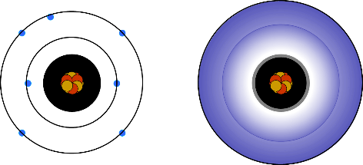

1. Describe what happens to the energy of electrons involved in bonding when forming an ionic bond.

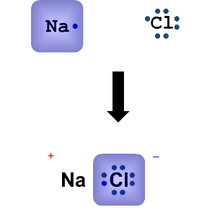

1. Describe what happens to the energy of electrons involved in bonding when forming a non-polar covalent bond.

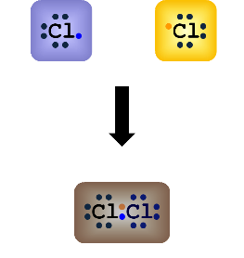

1. Describe what happens to the energy of electrons involved in bonding when forming a polar covalent bond.

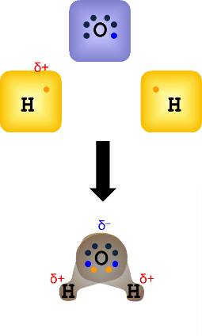

1. Explain why atoms involved in polar covalent bods have partial positive and negative charges.
2. Describe what is meant by the Continuum of Bonding Types

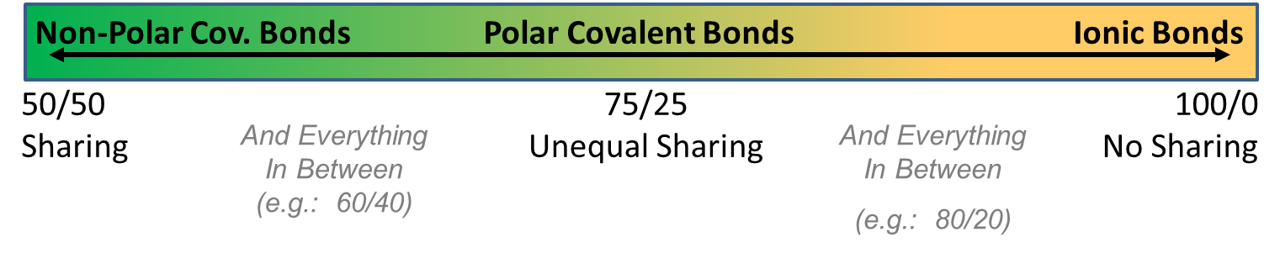

1. What determines the strength of a chemical bond [as experienced in Biological (*i.e aqueous*) Systems].
2. Describe generally how an atoms electronegativity is related to how close it is to having its octet

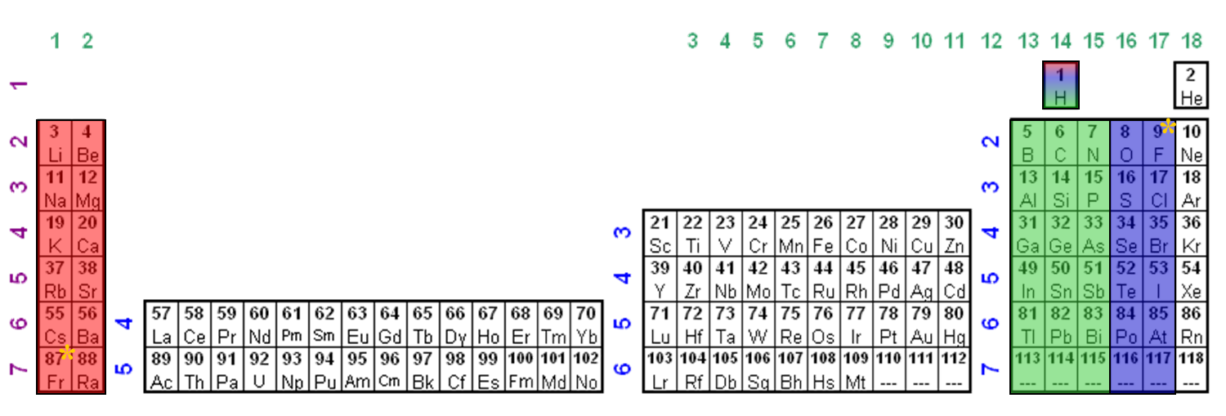

1. Why in the above periodic table of electronegativities is H placed in the middle above C. What do they have in common?
2. Explain how the relative electronegativities determines the type of bond that will form between two atoms.
3. Classify each of the following as Non-Polar Covalent, Polar Covalent, and Ionic. *Make sure you understand the reason for each.*
   1. C-C
   2. C-H
   3. HCl
   4. KI
   5. NaCl
   6. NaI
   7. N-H
   8. O=O
   9. O-H